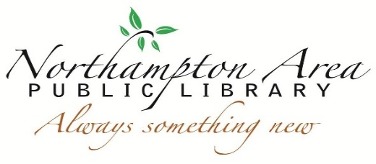

Northampton Area Public Library Mobile Hotspot Lending Policy

The Northampton Area Public Library is collaborating with T-Mobile to offer mobile hotspots to our patrons. Mobile hotspots are an easy to use device that connects your laptop, tablet, and other Wi-Fi enabled devices to the internet.

The library mobile hotspot program allows library card holders to access unlimited, high-speed internet service anywhere a T-Mobile signal can be received. The library currently offers five mobile wireless hotspots for checkout. These units can offer up to 4G LTE service and are perfect for travel, schoolwork, job hunting, and more.

How it works

Who can check out a device?
Northampton Area Public Library card holders that are 18 years and older that have accounts in good standing (no overdues or fines over $5.00) may check out a device.

How long can I keep it?
You can borrow a hotspot for one week. You may renew the mobile hotspot one time if there is no one on the waiting list.

How much does it cost?
It is $1.00/week to borrow the device. It is $1.00 per day late fee. Mobile hotspots will be deactivated on the first day they are overdue.

Can I reserve a hotspot to check out for a particular date and time?
No. You can place holds on the mobile hotspots, but we cannot guarantee their availability for a specific date or time. Mobile hotspots are available on a first-come/first-served basis like all our library materials.

What happens if I lose or break the hotspot?
You are expected to take good care of the mobile hotspot while it is checked out to you. If the mobile hotspot becomes lost or damaged $90 will be applied to your account.

Can I use the mobile hotspot outside of the U.S.?
No. The mobile hotspots only work in the U.S.

How do I return it?
You can return the mobile hotspot inside the Library. Please do not attempt to put it in the book or media drop. You must return the device with all the original packaging and accessories. Failure to return all items will result in charges to your library account.

What other information should I know about borrowing a mobile hotspot?
Hotspots must be kept in a temperature-controlled environment (not left in vehicles or in extreme temperatures).

Charger that is included is to be used for the hotspot only, not other devices. Conversely, no other charger should be used to charge the hotspot.

Hotspot should not be plugged in and charging all the time.

If there are any problems with the mobile hotspot, the Library should be contacted immediately.

The Library is not responsible for any liability, damages, or expense resulting from the use of the mobile hotspot.

What information about my Internet usage, if any, is tracked by the Library?
The Library does not track your internet usage. While using the Library’s hotspot you are governed by the same rules as our Internet Access Policy.

Parents and guardians are responsible for a child’s use of the mobile hotspot and the material accessed. The Northampton Area Public Library is not responsible for the internet’s content, data collected, or transmitted via a mobile hotspot, or for any misuse of copyrighted material or any other violation of law.

This policy is subject to change at any time without notice. Updates to the policy may be obtained from the Library.

Patron signature: ______________________________________________ Date:___________

Approved by the Board of Trustees: December 18, 2017
Approved updated version: December 9, 2021

